
CONFIDENTIAL CS/NOV 2026/CSC429

UNIVERSITI TEKNOLOGI MARA FINAL EXAMINATION

COURSE
COURSE CODE
EXAMINATION TIME
COMPUTER ORGANIZATION AND ARCHITECTURE

CSC429
NOVEMBER 2026
3 HOURS

INSTRUCTIONS TO CANDIDATES

- This question paper consists of two (2) parts: PART A (10 Questions) PART B (1 Question)

- Answer ALL questions in the Answer Booklet. Start each answer on a new page.

- Do not bring any material into the examination room unless permission is given by the invigilator .
- Please check to make sure that this examination pack consists of: i) the Question Paper
  - an Answer Booklet - provided by the Faculty

- Answer ALL questions in English.

DO NOT TURN THIS PAGE UNTIL YOU ARE TOLD TO DO SO

This examination paper consists of 4 printed pages.

PART A (80 MARKS)
Answer ALL questions in this part.
QUESTION 1 (5 marks)
Draw the complete machine cycle and explicitly describe the function of each phase and the
location of its occurrence.
QUESTION 2 (5 marks)
- Why is the machine in zero computer generation known as a mechanical computer?
- Complete the following table with the appropriate answer.
Mechanical Calculatin Machine Difference Machine
Inventor
Function
QUESTION 3 (5 marks)
Question 1 is based on the following statement.
Step Reckoner and Mechanical Calculating Machine are introduced in Zero
generation. Both machines are used for simple calculation and mechanically
operated using manual intervention throughout each step of their operation.
- Name the inventors for each machine.
- Describe the main difference in term of the machines' functions.
- Which machine that uses binary numbering system that is fundamental in modern
computers' operation?
QUESTION 4 (5 marks)
- Identify the Von Neumann architecture input and output components based on the
excerpts from the web.
- Identify ONE (1) similarity and ONE (1) dissimilarity between the mechanical calculating
machine and Atanasoff Berry Computer.
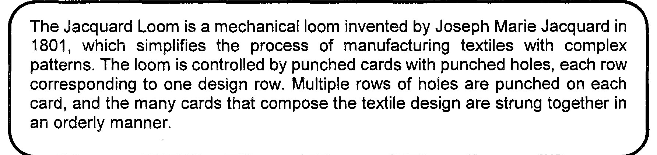
Figure 1: Excerpt from https://en.wikipedia.org/wiki/Loom
QUESTION 5 (10 marks)
- Why replacement algorithm for cache is needed?
- Discuss all different types of available replacement.
QUESTION 6 (10 marks)
- List the FOUR (4) classifications of parallel processors and provide examples for each.
- Discuss ONE (1) advantage of using cluster computer architecture.
QUESTION 7 (10 marks)
- Discuss the whole operation of the machine cycle and its respective responsible
computer components.
- Elaborate on what will happen in the machine cycle if the main memory is corrupted.
QUESTION 8 (10 marks)
- Convert 43.046875io to a floating point number in IEEE single precision format in
hexadecimal value form.
- Convert C478 OOOOh in IEEE single precision floating point number to decimal value form.
QUESTION 9 (10 marks)
- Registers are one of the main components of a CPU. Define the term registers, and list
TWO (2) types of registers.
- Briefly explain the Fetch and Decode operations of a Machine Cycle.
- Buses are the most common type of system interconnection. Discuss ONE (1)
difference between a dedicated bus and multiplexed bus.
QUESTION 10 (10 marks)
Replacement algorithm is used to determine which entry in a cache to flush to main
memory when it is desired to cache a new block of data.
- Which mapping function does not need to have a replacement algorithm?
- Describe FOUR (4) types of replacement algorithm.

PART B (20 MARKS)
Answer the question in this part.
QUESTION 11 (20 marks)
Question 1 is based on Figure 2 and Table 1
Write an appropriate program using conect assembly language notations to compute the
equation shown in Figure 2 using instructions for zero-address, one-address, and three-
address. The available instructions are provided in Table 1. The registers labeled A, B, C, and
D are fixed, while registers x, y, and z can be used temporarily. The final answer must be
stored in register z.
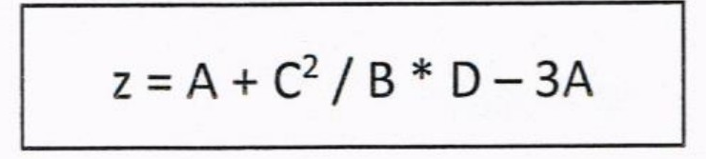
Figure 2
Table 1: lt/achine instruction
Zero-address | One-address | Three-address
PUSH p | LOAD p | ADD (p,q,r)
POP p | STOR p | SUB (p,q,r)
ADD | ADD p | MUL (p,q,r)
SUB | SUB p | DIV (p,q,r)
MUL | MUL p
DIV | DIV p

